Abstract. Key abilities for robots deployed in urban search and rescue tasks include autonomous exploration of disaster sites and recognition of victims and other objects of interest. In this paper, we present related open source software modules for the development of such complex capabilities which include hector slam for self-localization and mapping in a degraded urban environment. All modules have been successfully applied and tested originally in the RoboCup Rescue competition. Up to now they have already been re-used and adopted by numerous international research groups for a wide variety of tasks. Recently, they have also become part of the basis of a broader initiative for key open source software modules for urban search and rescue robots.
摘要。部署在城市里用于搜救任务的机器人的关键能力包括灾害地点的自动探索、受害者的急救 或者完成其他相关的目标。本文提出相关的开源软件模块 用于上述机器人的复杂能力的开发，这些软件模块包括：用于被破坏了的城市环境能够自定位和建图的hector slam。所有最初用于RoboCup营救竞赛的模块已经被的成功应用并测试。到目前为止，这些模块已经被为数众多的国际搜索团队重新使用和应用于广泛的各式的任务中去。 现如今，这些软件模块已经变成一个更广泛的用于城市搜救机器人的主要的开源软件模块项目的基础部分。
- Introduction
1.引言
While robots used for Urban Search and Rescue (USAR) tasks will remain mainly tele-operated for the immediate future when used in real disaster sites, increasing the autonomy level is an important area of research that has the potential to vastly improve the capabilities of robots used for disaster response in the future.
The RoboCup Rescue project aims at advancing research towards more rescue robots [1]. Rescue robotics incorporates a vast range of capabilities needed to address the challenges involved, e.g. resulting from a degraded environment. The availability of re-useable and adaptable open source software can significantly reduce development time and increase robot capabilities while simultaneously freeing resources and, thus, accelerating progress in the field.
In this paper, we present open source modules that provide the building blocks for a system capable of autonomous exploration in USAR environments. Different modules have been applied with great success in RoboCup Rescue and other applications, both by Team Hector (Heterogeneous Cooperating Team of Robots) of TU Darmstadt and numerous other international research groups.
Robot Operating System (ROS) [2] is used as the robot middleware for the software modules. It has been widely adopted in robotics research and can be considered a de-facto standard. The provided modules have also become part of a recently established, broader initiative of the RoboCup Rescue community for providing standard software modules useful for USAR tasks [3].
虽然在未来的一段时间里，当机器人用于实际灾难地点的USAR任务的时候，依然主要是远距离遥控的，但是在未来，增加（机器人的）自动化水平是一个重要的研究领域，并具有潜力极大地促进灾难响应机器人的能力。
RoboCup援救项目旨在推动研究朝着（研究出）更多有能力的搜救机器人（的方向发展）。救援机器人合并了广泛的被需要去处理相关的挑战的能力，比如说从被破坏的环境．这种可复用的和可修改的开源软件明显的减少开发时间，并且在同时释放资源和加速某些方面的处理速度 方面增加机器人的能力．
本文，我们展示在USRA环境下的一个开源模块，它为能胜任自动探索的系统提供建筑物障碍.不同的模块已经被成功的应用于RoboCup救援或者其他应用, 包括Team Hector (Heterogeneous Cooperating Team of Robots) of TU Darmstadt 和数目众多的其他国际研究团队.
ROS被用作机器人软件模块的中间件.它已经被广泛的应用于机器人的研究 并且可以被认为是一种事实上的标准.提供的模块也已经成为RoboCup救援机构最近建立的、更广泛倡导的用于为USAR任务提供有用的标准软件模块.
2.Kohlbrecher et al.
At the RoboCup competition, we mainly use the Ackermann-steered Hector UGV vehicle (Figure 1)[4]. While this method is in many ways more challenging than differential steering, we do not focus on these challenges in this paper, instead providing based on the Hector Lightweight UGV (Figure 1) that bears more similarity to differential drive vehicles commonly used for USAR tasks.
在RoboCup比赛，我们主要使用Ackermann-steered Hector 无人地面车辆。这种方式，在某些方式上来说比差动控制更具有挑战性，本文我们不讨论这些挑战，转而提供以Hector轻量级的与查分驾驶车辆更类似的无人地面车辆为基础的广泛地用于USAR任务（？）。
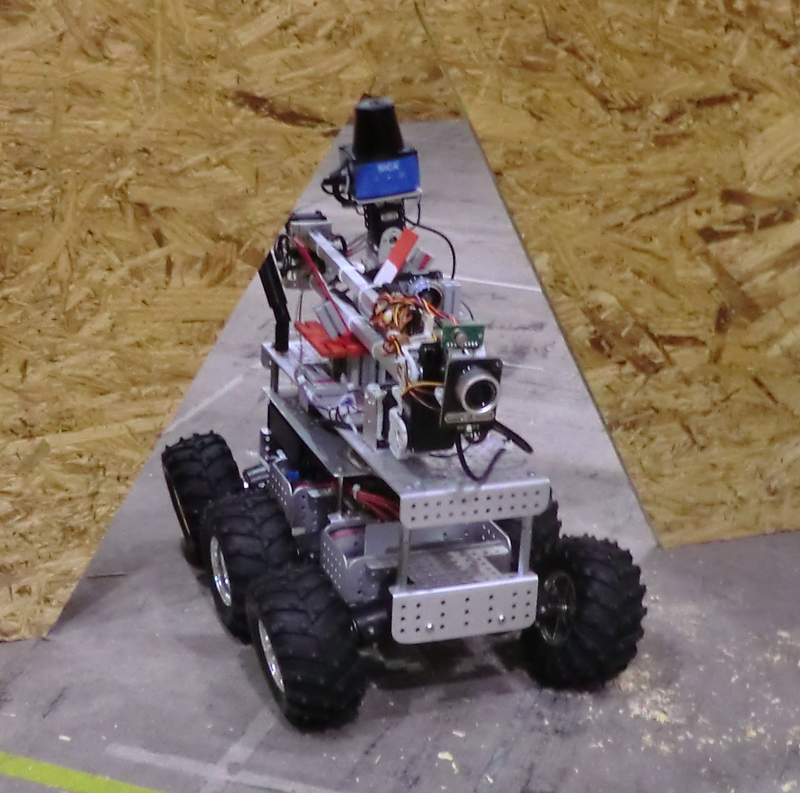
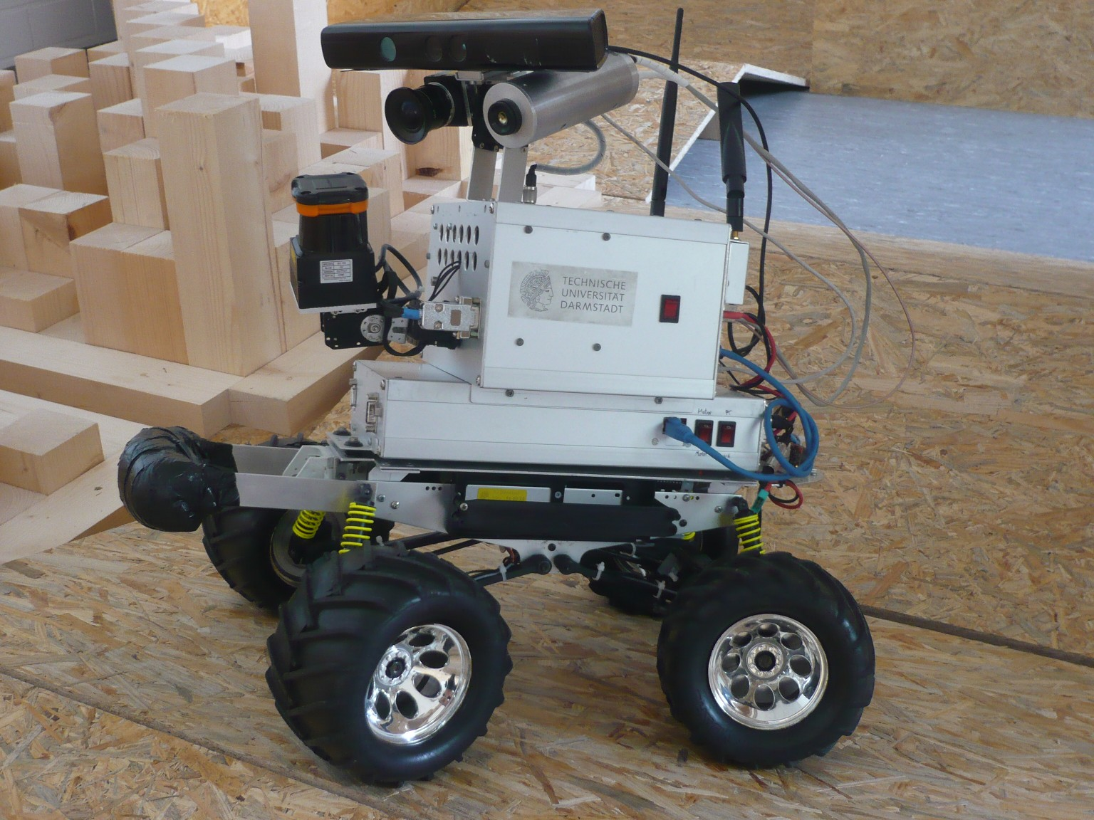

Fig. 1. Robots used by Team Hector. Left: Hector UGV based on Kyosho Twin Force
chassis. Right: Hector Lightweight UGV based on “Wild Thumper” robot kit.
图1.Team Hector使用的机器人。左边：以Kyosho Twin Force 为基础的Hector UGC Force底盘。右边：以Wild Thumper机器人工具集为基础的Hector Lightweight UGV。
1.1 Related Work
Research in Simultaneous Localization and Mapping (SLAM) and exploration of
unknown environments received a lot of attention in recent years, with impressive
results being demonstrated. Many of these results often cannot be reproduced
due several reasons, like a lack of standardized interfaces, closed source software
and limited robustness to different (e.g. environmental) conditions.
Evaluation of state-of-the-art visual SLAM approaches [5], [6] in the stan-
dardized RoboCup Rescue setting showed promising results, but consistent lo-
calization/mapping as with the system described in this paper could not be
achieved so far, as ramps and other obstacles lead to jerky vehicle motion and
pose significant challenges to any SLAM system.
The RoboCup Rescue Robot League competition provides especially chal-
lenging scenarios, as the competition setting enforces strict constraints on the
time and environment for robot operation.
1.1相关的工作
近年来，SLAM和未知环境的探索的研究得到了很多的关注，令人印象深刻的示例得到展示。因为多种原因很多结果不能重现，比如缺少标准接口，闭源的软件以及对于不同情景的有限鲁棒性。

